WEEK 4: 1. Spring Rest Handson (Solutions)
[Note: Using Intellij Idea instead of Eclipse]
#1
Create a Spring Web Project using Maven
Follow steps below to create a project:
- Go to https://start.spring.io/
- Change Group as “com.cognizant”
- Change Artifact Id as “spring-learn”
- Select Spring Boot DevTools and Spring Web
- Create and download the project as zip
- Extract the zip in root folder to Eclipse Workspace
- Build the project using ‘mvn clean package -Dhttp.proxyHost=proxy.cognizant.com -Dhttp.proxyPort=6050 -Dhttps.proxyHost=proxy.cognizant.com -Dhttps.proxyPort=6050 -Dhttp.proxyUser=123456’ command in command line
- Import the project in Eclipse "File > Import > Maven > Existing Maven Projects > Click Browse and select extracted folder > Finish"
- Include logs to verify if main() method of SpringLearnApplication.
- Run the SpringLearnApplication class.

SME to walk through the following aspects related to the project created:

- src/main/java - Folder with application code
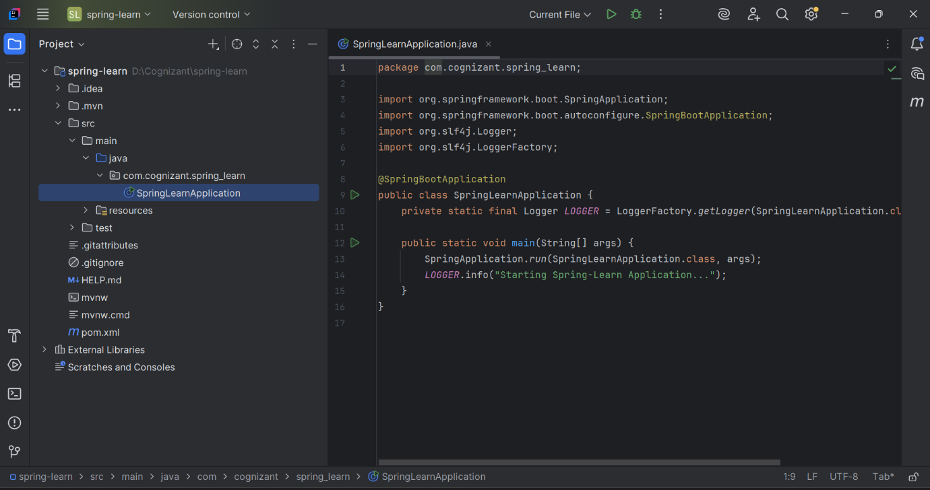

- src/main/resources - Folder for application configuration
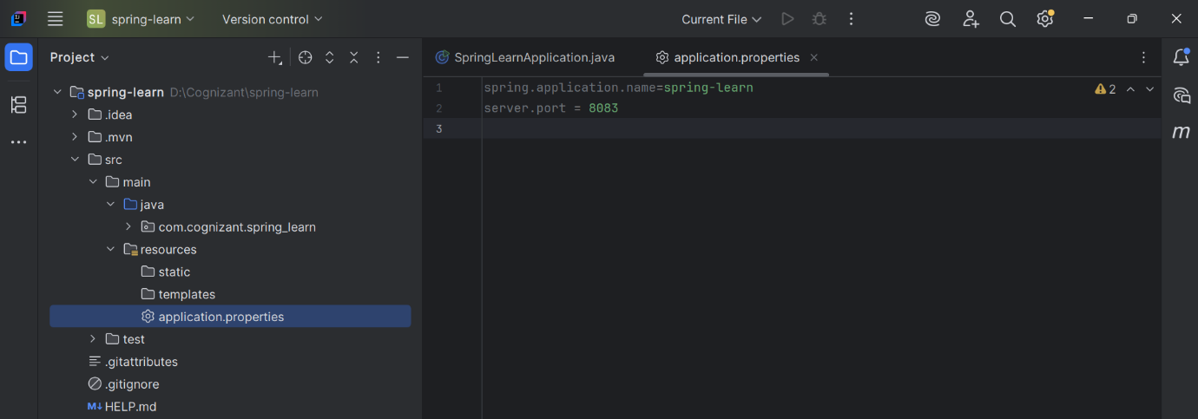

- src/test/java - Folder with code for testing the application
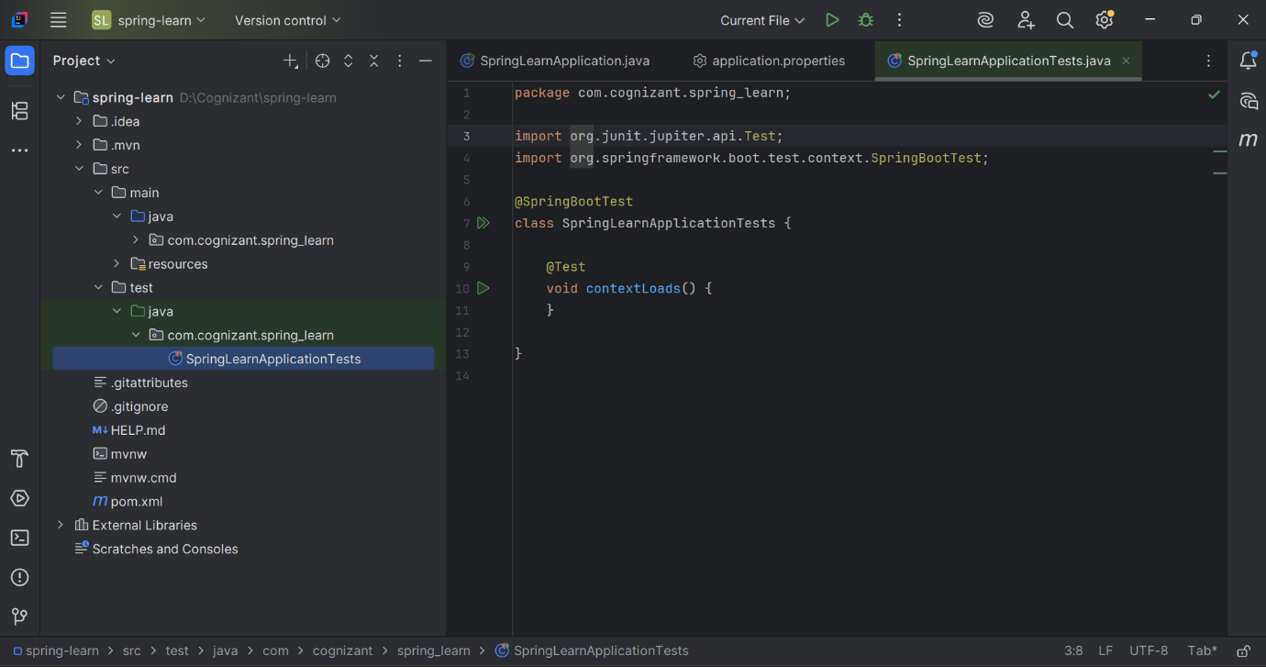

- SpringLearnApplication.java - Walkthrough the main() method.
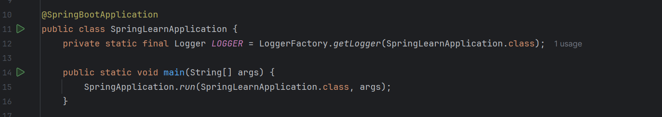

- Purpose of @SpringBootApplication annotation
Answer:
- @Springboot Annotation is a Combination of:
  - @Configuration: Defines configuration class
  - @EnableAutoConfiguration: Enables auto-config features
  - @ComponentScan: Scans packages for Spring components
So this single annotation makes Spring Boot powerful and quick to start.

- pom.xml
  - Walkthrough all the configuration defined in XML file

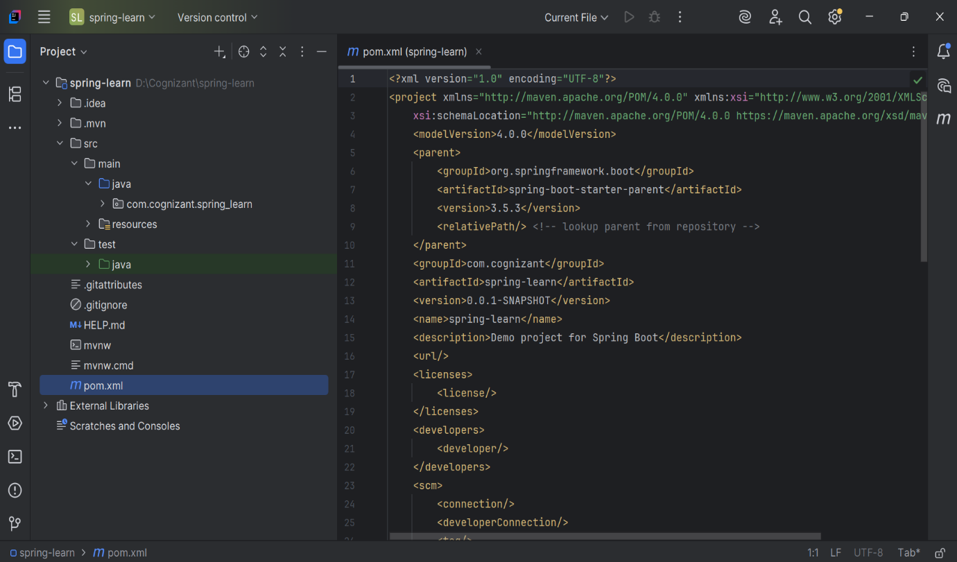

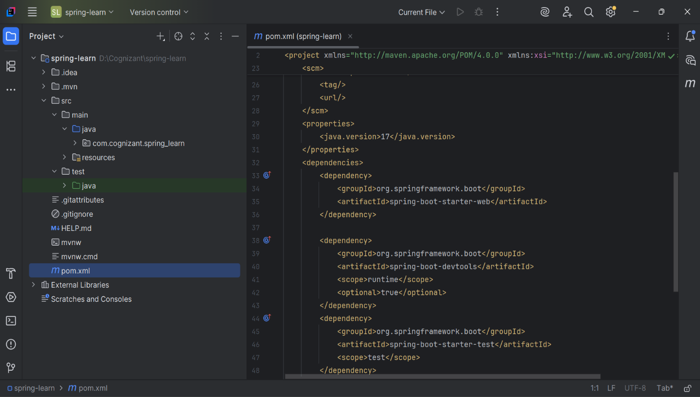
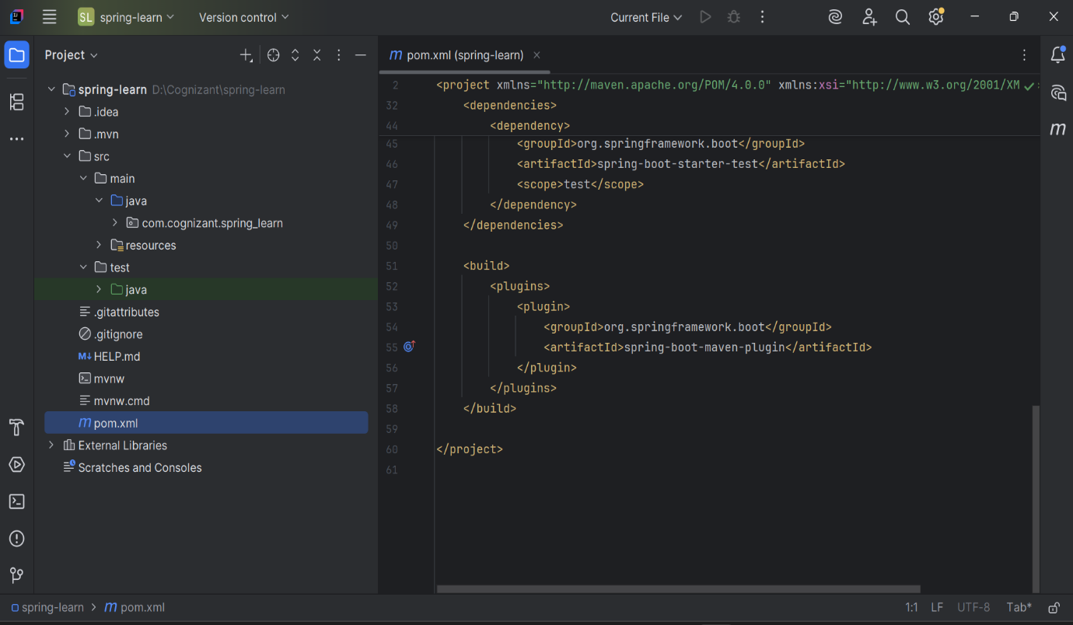

  - Open 'Dependency Hierarchy' and show the dependency tree.
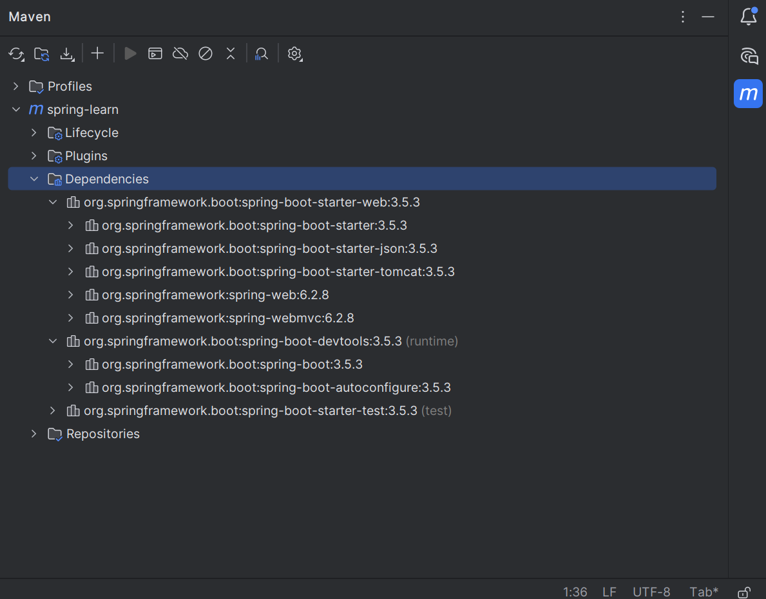

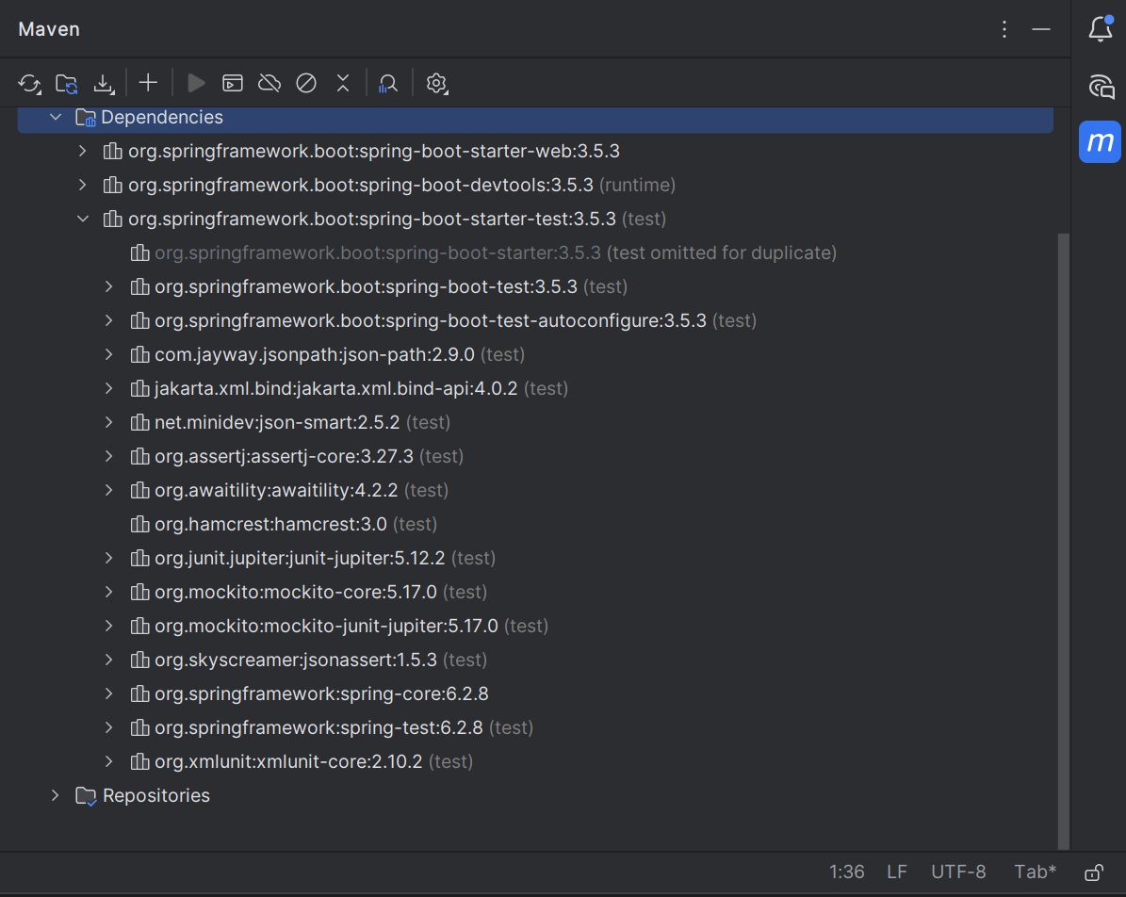

==================================================================================

#2
Spring Core – Load Country from Spring Configuration XML
An airlines website is going to support booking on four countries. There will be a drop down on the home page of this website to select the respective country. It is also important to store the two-character ISO code of each country.

Code | Name
US | United States
DE | Germany
IN | India
JP | Japan

Above data has to be stored in spring configuration file. Write a program to read this configuration file and display the details.
Steps to implement:

- Pick any one of your choice country to configure in Spring XML configuration named country.xml.
- Create a bean tag in spring configuration for country and set the property and values
<bean id="country" class="com.cognizant.springlearn.Country">
<property name="code" value="IN" />
<property name="name" value="India" />
</bean>
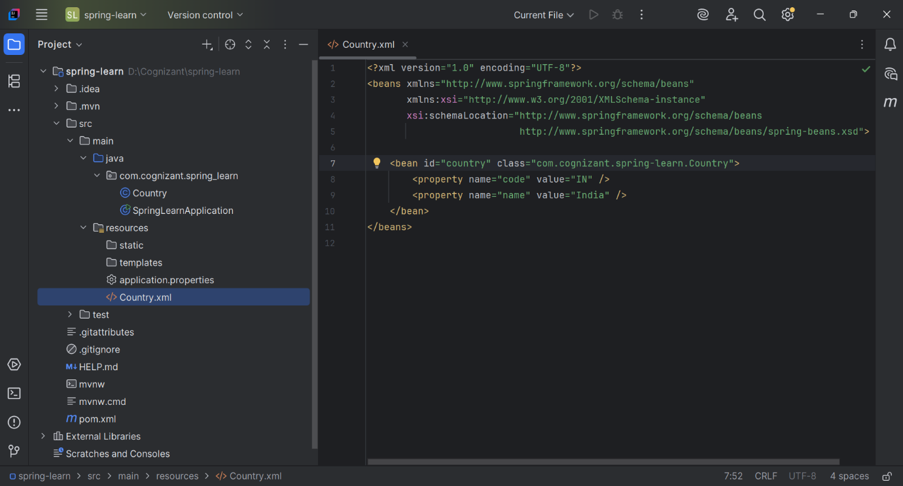

- Create Country class with following aspects:
  - Instance variables for code and name
  - Implement empty parameter constructor with inclusion of debug log within the constructor with log message as “Inside Country Constructor.”
  - Generate getters and setters with inclusion of debug with relevant message within each setter and getter method.
  - Generate toString() method

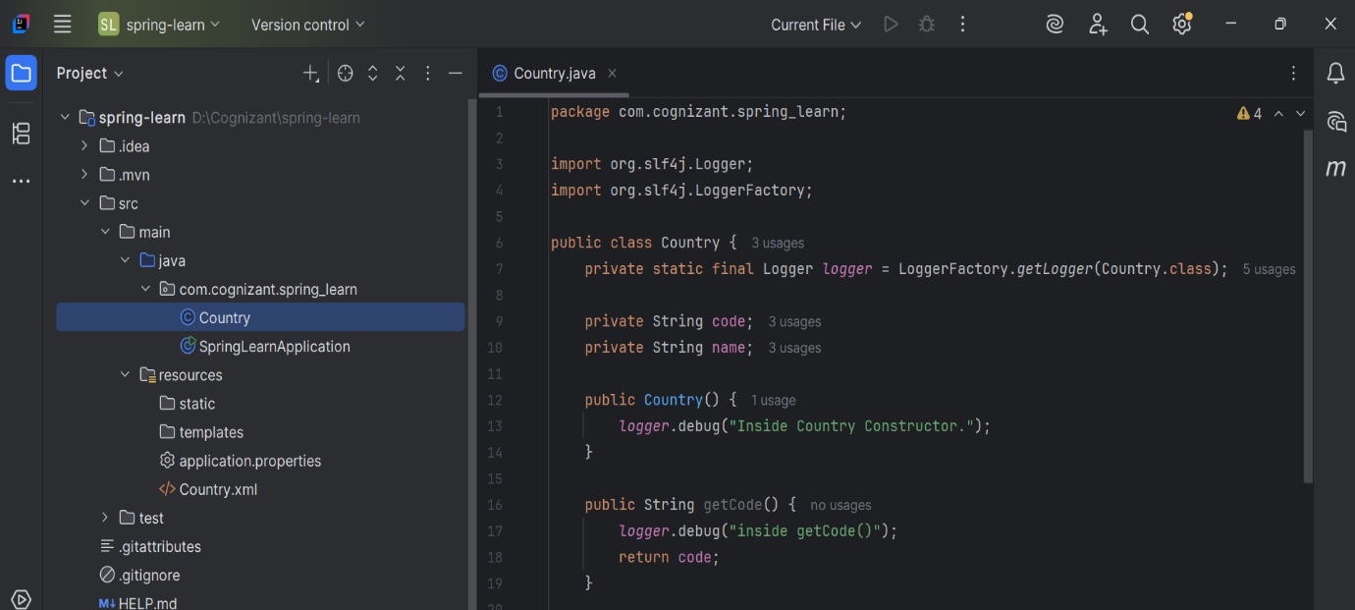

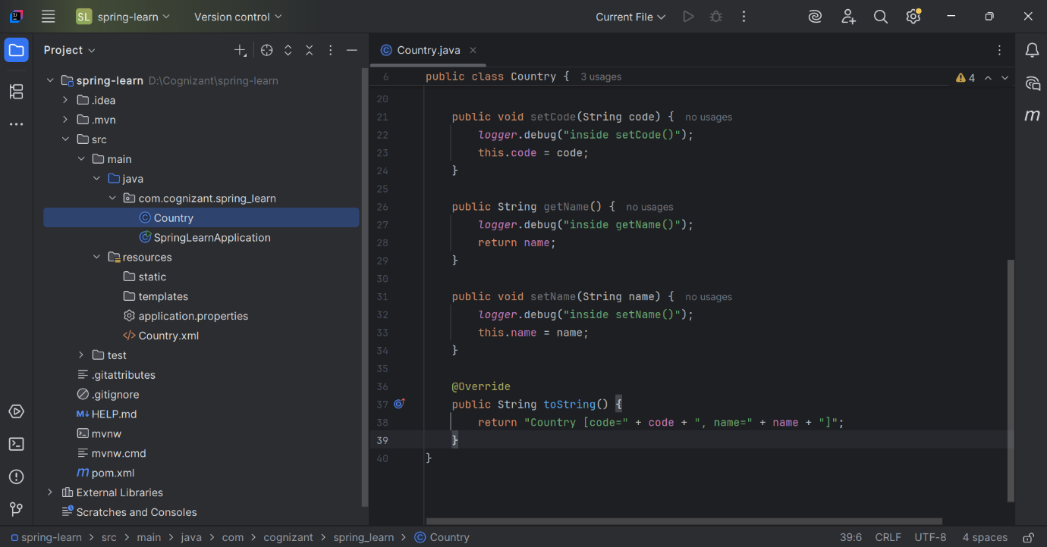

- Create a method displayCountry() in SpringLearnApplication.java, which will read the country bean from spring configuration file and display the country details. ClassPathXmlApplicationContext, ApplicationContext and context.getBean(“beanId”, Country.class). Refer sample code for displayCountry() method below.
ApplicationContext context = new ClassPathXmlApplicationContext("country.xml");
Country country = (Country) context.getBean("country", Country.class);
LOGGER.debug("Country : {}", country.toString());
- Invoke displayCountry() method in main() method of SpringLearnApplication.java.
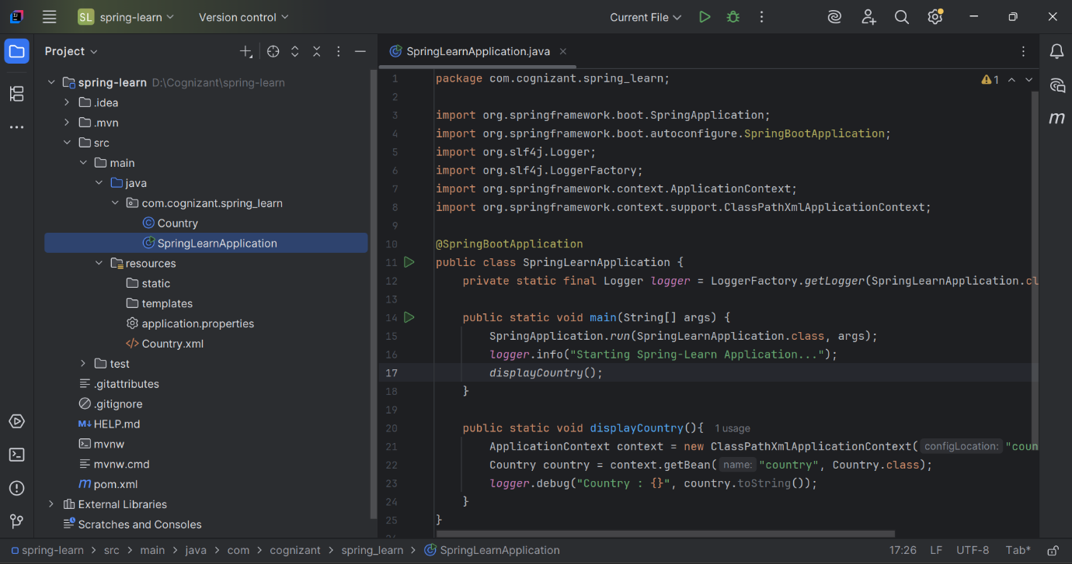

- Execute main() method and check the logs to find out which constructors and methods were invoked.
OUTPUT:
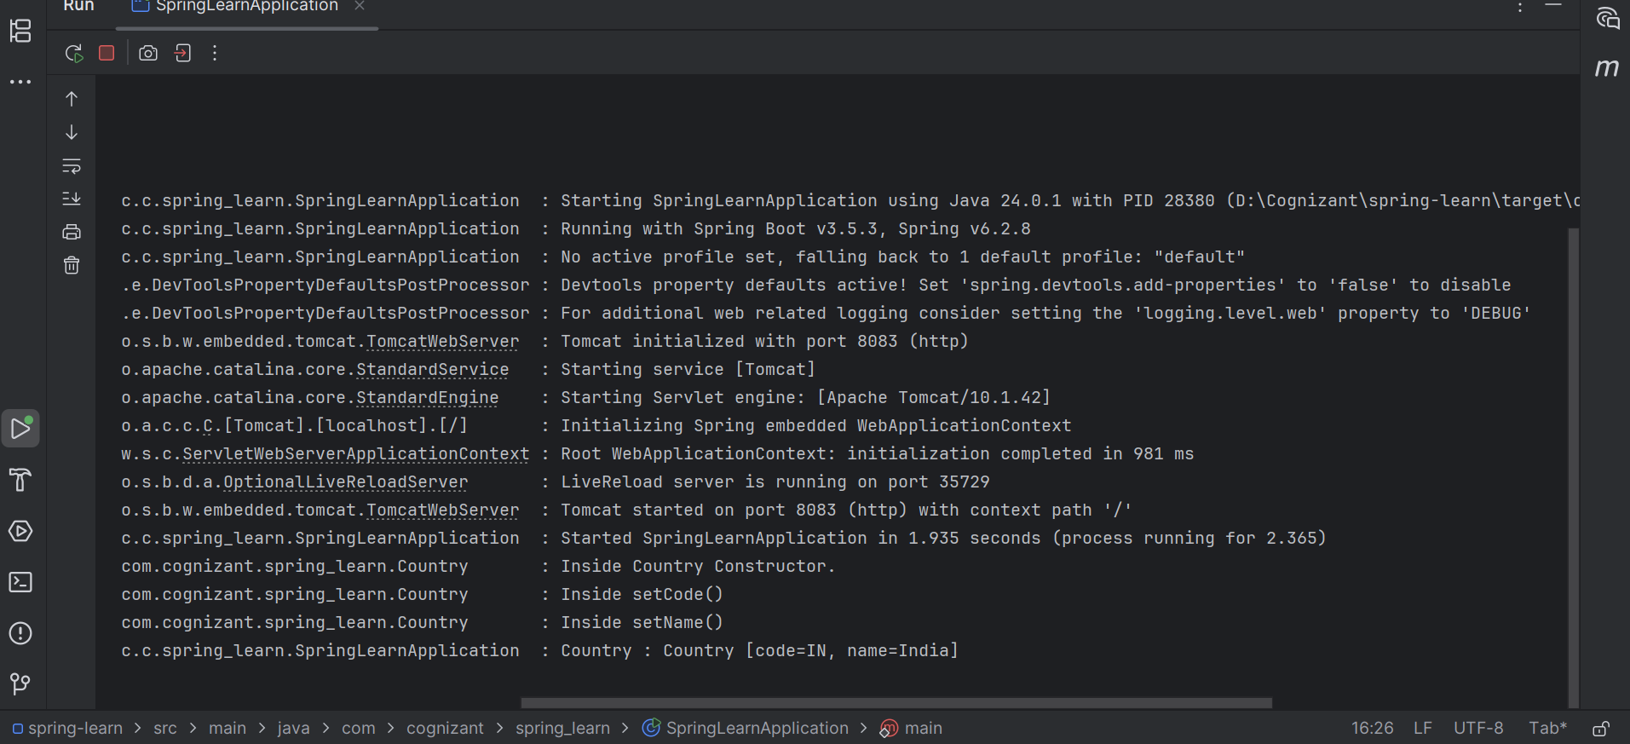

SME to provide more detailing about the following aspects:
- bean tag, id attribute, class attribute, property tag, name attribute, value attribute
<bean id="country" class="com.cognizant.springlearn.Country">
<property name="code" value="IN" />
<property name="name" value="India" />
</bean>

Element | Description
<bean> | Declares a Spring bean
Id | Unique identifier for the bean in Spring container
Class | Fully qualified class name of the bean
<property> | Used to inject values into fields (via setters)
name | Corresponds to the setter method (setName())
value | Literal value to inject into the field

- ApplicationContext, ClassPathXmlApplicationContext
Term | Description
ApplicationContext | Central interface to access Spring beans
ClassPathXmlApplicationContext | Loads XML-based Spring configuration from classpath

- What exactly happens when context.getBean() is invoked
- Spring container searches for a bean with ID "country" in country.xml
- Instantiates Country object via no-arg constructor
- Injects values into code and name using setCode() and setName() methods
- Returns the fully initialized Country object.

